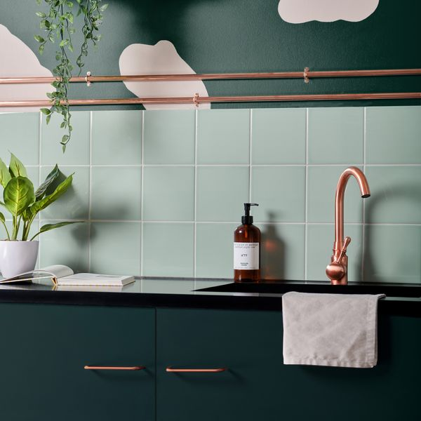

**Pistachio Pick n’ Mix Gloss Tiles:**

## **Product DESCRIPTION**

Soothing and serene, our Pistachio Pick n’ Mix Gloss Tiles are designed in an uplifting shade of green, with a shimmering gloss finish that catches the light for a space-enhancing look. Made from durable ceramic, these square-shaped tiles are a great base shade for any interior design scheme, as they effortlessly match a range of different colours, patterns and styles.

**What’s special about these tiles?**

> Soothing shade of green

> Durable ceramic

> Shimmering gloss finish

> Effortlessly versatile

## **Product Info**

* Product ID: 45087
* Tiles Per SQM: 44.444444444444
* Sale by: Per SQM
* Size: 150x150x8mm
* Weight: 0.28 KG
* Material Type: Ceramic
* Finish: Gloss
* Colour: Green
* Suitability: Walls
* Rectified Edge: No
* Underfloor Heating: Yes
* Thickness (mm): 8